# Title: On the “IMAX Laser's” page. Choosing another theater name at the right upper-corner of the page doesn't switch to the chosen theater.

**Priority:** Medium

**Severity:** S4 Minor

**Environment:** Browser Mozilla Firefox 118.0.1 (64-bit)

**Steps to reproduce**

1. Go to the Main page <https://multiplex.ua/>

2. Click “IMAX” on the header of the page:



3. Click a “down” arrow near to the “Лазер” word

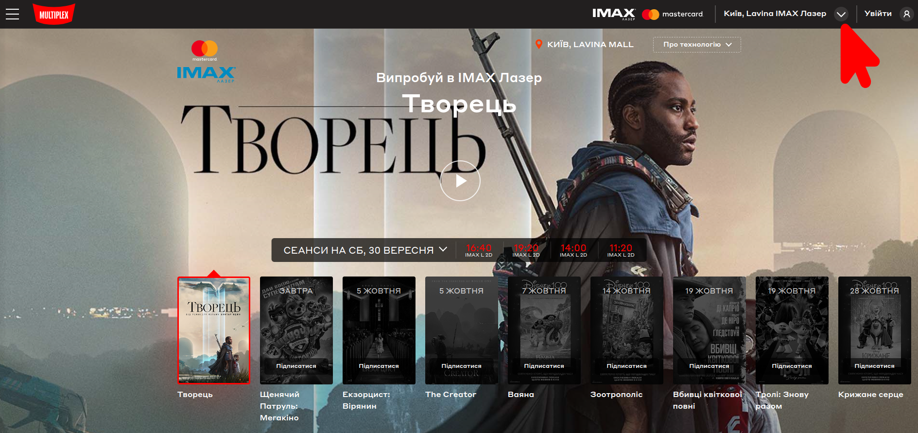

4. In a drop-down menu, click on the “Проспект” theater title (or on any other title of the theater)

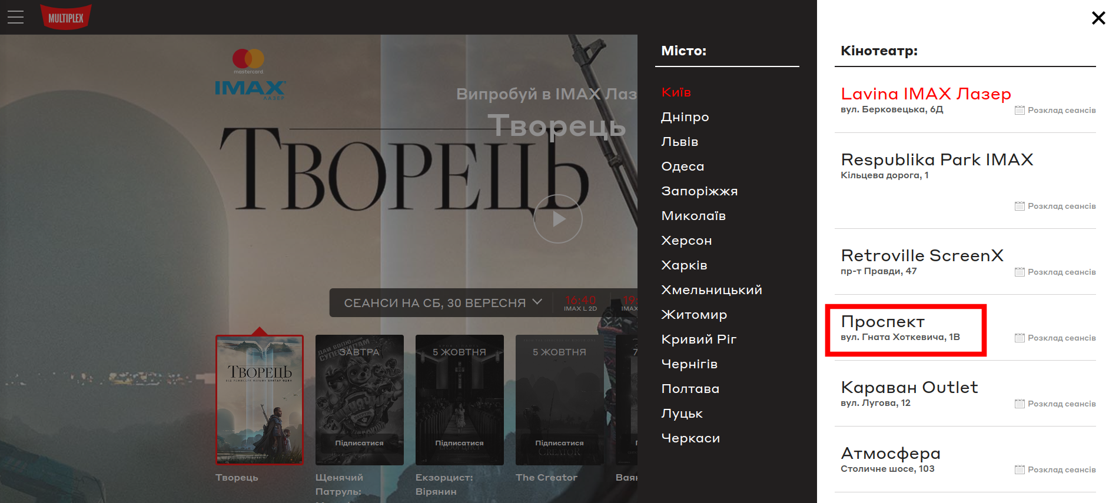

**Actual result**

The title of the theater is not changed to “Проспект” on the header of the page. We still see the initial title:

**Expected result**

The title of the theater is changed to “Проспект” title (or to any other chosen in the drop-down menu title) on the header of the page.

*Screenshot from* ***Jira****:*

